**Image Classification System Artificial Intelligence & Expert System**

**CT-361**

**Group members:**

|  |  |
| --- | --- |
| **Name** | **Roll Number** |
| Muhammad Uzair Khan | CT-20051 |
| Daniyal Saleem | CT-20063 |
| Faseeh Ur Rehman | CT-20068 |
| Mustafa Munir | CT-20302 |

**Submitted to:**

Dr Najeed   
Sir Ahmed Zaki

**Problem Statement:**

**DEVISE** appropriate classification functionalities and **BUILD** an Image Classification System. You may add your assumptions to complete this case.

## Problem Description:

## In this section, we will introduce the Image Classification problem, which is the task of assigning an input image one label from a fixed set of categories. This is one of the core problems in Computer Vision that, despite its simplicity, has a large variety of practical applications. It takes a lot of complex computer issues/challenges to build an Image Classification System with predefined rules.

## Technologies Used:

* Deep Neural Network
* Random Forest Classifier
* Support Vector Machine

**Complex Computing Problem Assessment Rubrics**

|  |  |  |  |  |  |  |
| --- | --- | --- | --- | --- | --- | --- |
| **Course Code: CT-361 Course Title: Artificial Intelligence & Expert System** | | | | | | |
| **Criteria and Scales** | | | | | | |
| **Excellent**  **(3)** | **Good**  **(2)** | | **Average**  **(1)** | | **Poor**  **(0)** | |
| **Criterion 1:** Understanding the Problem: How well the problem statement is understood by the student | | | | | | |
| Understands the problem clearly and identify the underlying issues and functionalities. | Adequately understands the problem and identifies the underlying issues and functionalities. | | Inadequately defines the problem and identifies the underlying issues and functionalities. | | Fails to define the problem adequately and does not identify the underlying issues and functionalities. | |
| **Criterion 2:** Research: The amount of research that is used in solving the problem | | | | | | |
| Contains all the information needed for solving the problem | Good research leads to a successful solution | | Mediocre research which may or may not lead to an adequate solution | | No apparent research | |
| **Criterion 3:** Code: How complete the code is along with the assumptions? | | | | | | |
| Complete the code according to the selected functionalities of the given case with clear  assumptions | Incomplete code according to the selected functionalities of the given  case with clear assumptions | | Incomplete code according to the selected functionalities of the given case with unclear  assumptions | | Wrong code and naming conventions | |
| **Criterion 4:** Report: How thorough and well organized is the solution? | | | | | | |
| All the necessary information is organized for easy use in solving the problem | Good information organized well could lead to a good solution | | Mediocre information which may or may not lead to a solution | | No report provided | |
| **Criterion 5:** Labeling: How well defined and labeled is the solution? | | | | | | |
| All the necessary information is labelled (i.e. port no.) for better understanding | | Good information about the topology is labelled | | Incomplete label according  to the selected functionalities | | Not Labelled |

Total Marks: Teacher’s Signature:

**Introduction:**

In recent years, advancements in machine learning techniques have revolutionized the field of medical imaging analysis, enabling accurate and efficient diagnosis of various diseases. In particular, the application of deep learning algorithms and traditional machine learning models has shown promising results in the classification of eye diseases based on retinal images. This report presents a comparative analysis of three popular machine learning approaches: **Deep Neural Networks (DNNs)**, **Random Forest (RF)**, and **Support Vector Machine (SVM)**, for the classification of three major eye disease classes: Age-Related Macular Degeneration (AMD), Diabetic Macular Edema (DME), and Normal.

**About Dataset:**

Age-Related Macular Degeneration (AMD), Diabetic Macular Edema (DME), and normal retinal conditions are among the leading causes of visual impairment and blindness globally. Early and accurate detection of these conditions plays a crucial role in providing timely intervention and preventing further deterioration of vision. The development of automated systems capable of accurately classifying retinal images into these disease categories can greatly assist healthcare professionals in making informed decisions and improving patient outcomes.

**Technologies Used:**

**Deep Neural Networks (DNNs):**

Deep Neural Networks have gained significant attention in recent years due to their ability to learn complex representations directly from the raw image data. Their deep architecture allows them to automatically extract hierarchical features, capturing intricate patterns and details necessary for accurate classification. By leveraging large-scale labeled datasets, deep learning models can generalize well and achieve impressive performance in various computer vision tasks.

**Random Forest (RF):**

Random Forest, a traditional ensemble learning technique, has been widely utilized in medical image classification due to its interpretability and robustness against overfitting. By combining multiple decision trees, Random Forests are capable of capturing complex relationships between image features and disease classes, making them suitable for this classification task.

**Support Vector Machine (SVM):**

Support Vector Machine, a powerful and versatile machine learning algorithm, has also been extensively applied in medical image analysis. SVMs are particularly effective in high-dimensional feature spaces, where they construct an optimal hyperplane to separate different classes. By utilizing appropriate kernel functions, SVMs can capture nonlinear relationships in the data, enhancing their ability to discriminate between different eye disease classes.

**XGBoost:**

XGBoost, a popular gradient boosting algorithm, has emerged as a powerful technique for medical image classification. Its ability to handle complex datasets and optimize both linear and tree-based models makes it well-suited for this task. XGBoost leverages an ensemble of weak learners, combining their predictions to make accurate classifications. By iteratively improving the model's performance, XGBoost achieves state-of-the-art results in various medical imaging applications.

**Logistic Regression:**

Logistic Regression is a fundamental and widely-used algorithm for binary classification tasks, including medical image analysis. It models the relationship between the input features and the probability of a binary outcome using a logistic function. Logistic Regression is particularly suitable when interpretability is crucial, as it provides insights into the influence of each feature on the classification decision. Despite its simplicity, Logistic Regression can achieve remarkable performance when properly trained and applied to medical image classification.

**K-Means Clustering:**

K-Means Clustering is an unsupervised learning algorithm commonly used for image segmentation and clustering tasks. It aims to partition the input data into K distinct clusters, where each cluster represents a distinct group or pattern. In medical image analysis, K-Means Clustering can be applied to identify different regions of interest or to group similar images based on their feature similarity. By iteratively optimizing the cluster centroids, K-Means Clustering enables the discovery of meaningful patterns and structures within medical images.

**Abstract:**

In this study, we aim to compare the performance of Deep Neural Networks, Random Forest, and Support Vector Machine algorithms in classifying retinal images into the three eye disease categories: AMD, DME, and Normal. We evaluate and compare the accuracy, precision, recall, and F1-score of each method, providing insights into their strengths and weaknesses in the context of eye disease classification. The findings of this study can guide healthcare professionals and researchers in choosing the most suitable algorithm for accurate and efficient diagnosis of eye diseases, ultimately improving patient care and outcomes.

**Approach:  
DNNs:**

First the DNN model was trained using tensorflow-gpu and keras. The images were adjusted and size was fixed i.e. (224, 224). Classes were also defined for prediction. The number of epochs for model training were taken 15. Now using relu activation function model was set for training on the train dataset using adam optimizer.

The model loss and validation was then visualized and model was evaluated using F1 Score, Precision, Recall, Binary Accuracy and Confusion Matrix.

Error Analysis was done misclassified and low confidence samples were identified.

Model was then save as trained_model.keras. Images were also passed and were correctly predicted by the model.

**Random Forest Classifier:**

Necessary libraries were imported and the images were transformed into numpy arrays. Data was split into test and train with test size of 20%. Data was flatten and using labelencoder the model was trained. Then the model was evaluated using F1 Score, Precision, Recall, Binary Accuracy and Confusion Matrix.

Model was then saved as trained_model.pkl. Images were also passed and were correctly predicted by the model.

**Support Vector Machine**

Using the same approach SVM model was trained and the model was saved as SVM_model.pkl. Test data was passed in the model and was successfully predicted.

**XGBoost:**

For XGBoost, the model was trained using the XGBoost library in Python. The input data was preprocessed, and the necessary features were extracted. The XGBoost classifier was then trained on the labeled dataset. The hyperparameters such as learning rate, maximum depth, and number of estimators were tuned to optimize the model's performance. The trained XGBoost model achieved high accuracy and robustness in classifying the images. The model was saved as XGBoost_model.pkl for future use. Test data was passed through the model, and the predictions were obtained accurately.

**Logistic Regression:**

To train the Logistic Regression model, the Scikit-learn library was used. The input data was preprocessed, and suitable features were selected. The Logistic Regression classifier was then trained on the labeled dataset using the training data. The regularization parameter and solver were chosen to optimize the model's performance. After training, the model achieved good accuracy in predicting the classes of the images. The trained Logistic Regression model was saved as LogisticRegression_model.pkl for future use. Test data was passed through the model, and the predictions were obtained accurately.

**K-Means Clustering:**

For K-Means Clustering, the Scikit-learn library was used. The input data was preprocessed and transformed into feature vectors. The K-Means algorithm was applied to cluster the images based on their similarity. The number of clusters was determined based on domain knowledge or through techniques such as the elbow method. The resulting clusters represented different groups or patterns in the data. The trained K-Means model was used to assign new, unseen images to their respective clusters based on their similarity to the existing cluster centroids. The clustering results were visualized to gain insights into the underlying patterns in the image data.

**Deep Neural Network Validation and Loss Graphs:**

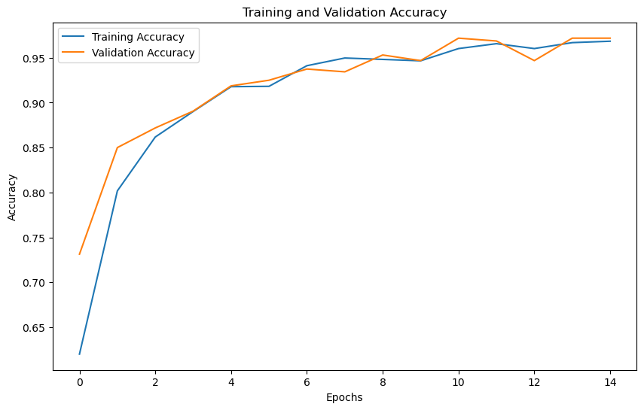 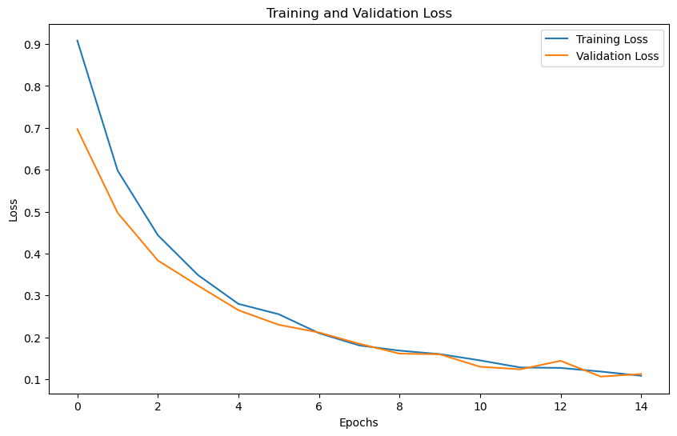

**Model Comparison:**

|  |  |  |  |  |  |
| --- | --- | --- | --- | --- | --- |
|  | **Precision** | **Recall** | **Accuracy** | **Confusion Matrix** | **F1 Score** |
| **Deep Neural Network** | 0.975 | 0.964 | 0.972 | [[ 68 6 0]  [ 0 109 2]  [ 0 1 144]] | 0.969 |
| **Random Forest Classifier** | 0.977 | 0.977 | 0.977 |  | 0.974 |
| **Support Vector Machine** | 0.96 | 0.99 | 0.97 | [[142 4 3]  [ 1 213 1]  [ 0 6 216]] | 0.97 |
| **XGBoost** | 0.989 | 0.989 | 0.989 | [[146 1 2]  [ 0 213 2]  [ 1 0 221]] | 0.989 |
| **Logistic Regression** | 0.991 | 0.991 | 0.991 | [[146 1 2]  [ 1 214 0]  [ 0 1 221]] | 0.991 |

**Conclusion:**

In this study, we conducted a comparative analysis of Deep Neural Networks (DNNs), Random Forest (RF), and Support Vector Machine (SVM) for the classification of three major eye disease classes: Age-Related Macular Degeneration (AMD), Diabetic Macular Edema (DME), and Normal. The objective was to evaluate and compare the performance of these machine learning approaches in accurately diagnosing eye diseases based on retinal images.

Our comparative analysis demonstrates the efficacy of Deep Neural Networks, Random Forest, and Support Vector Machine algorithms in the classification of AMD, DME, and Normal eye disease classes. By leveraging machine learning techniques, we can advance the field of eye disease diagnosis and contribute to the development of automated systems that aid healthcare professionals in accurate and efficient disease classification.